First Time Homebuyer Credit for 2008 Purchases
- Maximum credit $7,500
- Repayment over 15 years - starting in the tax year 2010 return
- Purchases must have been completed between 4/9/2008 and 12/31/2008

First Time Homebuyer Credit for 2009 and 2010 Purchases
- Credits that were claimed on 2009 and 2010 tax returns do not have to be repaid unless certain repayment triggers are met. This is OUT OF SCOPE.

Repayments of Credit for 2008 purchases (Sources: Pub 17 or Form Instructions for Form 5405)
- Repayments for 2008 purchases are normally repaid in 15 equal annual installments beginning in 2010.
- The taxpayer may or may not receive a letter from the IRS for TY 2017. If the taxpayer received the First Time Homebuyer Credit in Year 2008, you can use the First Time Homebuyer Credit Account Look up tool to determine repay amounts and account balance. There is a link to the First-Time Homebuyer Credit Account Look up Tool on the Preparer’s page of Tax Prep4Free under the Internal Revenue Service Useful Links.
- If the taxpayer bought the home in 2008 and owned and used it as their main home for all of 2017, the return is in scope.
- If the taxpayer dies, repayment of the credit is not required.
- If the taxpayer filed a joint return in 2008 and one of them died, the surviving spouse must pay back his or hers half of the credit. The remaining half (the half belonging to the deceased spouse) does not have to be repaid.
- If the taxpayer made a payment in TY2016 that was greater than the minimum, the minimum payment for TY2017 is still 1/15th of the original credit amount or the total remaining due. The loan will be paid off sooner than 15 years.
- Any other situations requiring use of form 5405 and are OUT OF SCOPE.

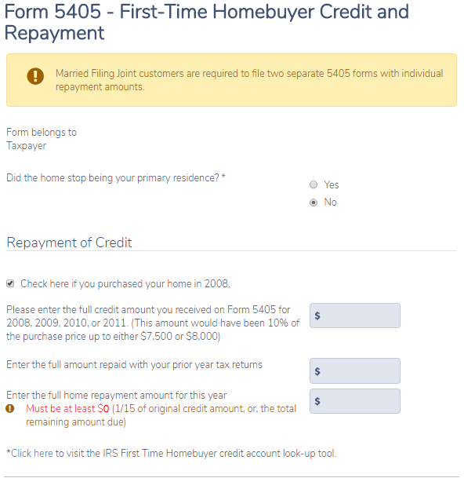
500
3500
7500
Enter applicable information.
If not purchased in 2008, the return is OUT OF SCOPE.
If the answer is “Yes” the return is OUT OF SCOPE

If the return filing status is MFJ a separate 5405 must be completed for TP and SP with ½ the amounts entered on each 5405. In a MFJ return, the TSO form asks for ½ the information on each form.

TSO automatically puts the total amount of repayment on the 1040, line 60b

For a standard repayment, the 5405 is not included in the return. The amount is just entered on line 60b. TSO handles this properly.

